You can check your Solution here: <https://judge.softuni.bg/Contests#!/List/ByCategory/102/Data-Structures-Exercises>

# C# Tutorial

## Create our Project

### When you have skeleton, just run it and skip what version is your project and next steps

### The “Judge” works with a version .NET Framework 4.6.1 or older

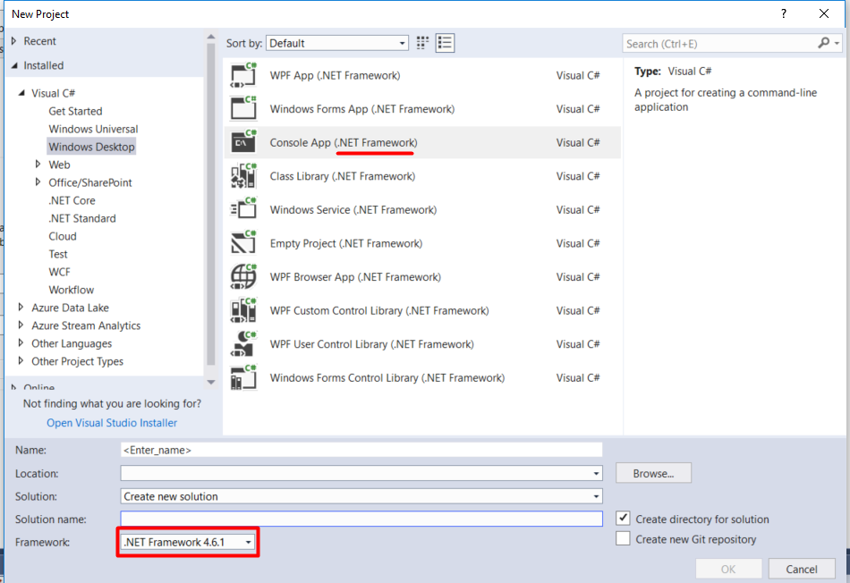

### In this case we create new Class “ArrayList”

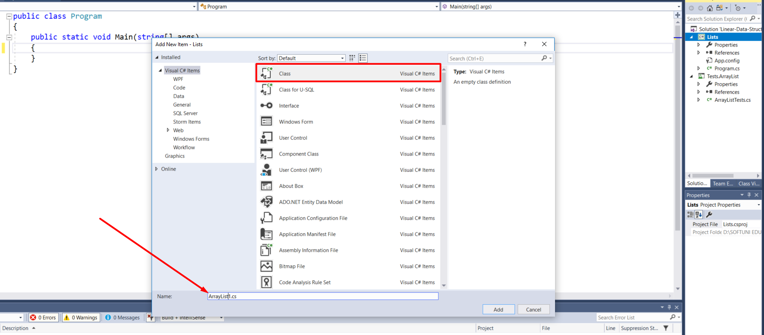

Then, we remove namespaces from the class and make our class public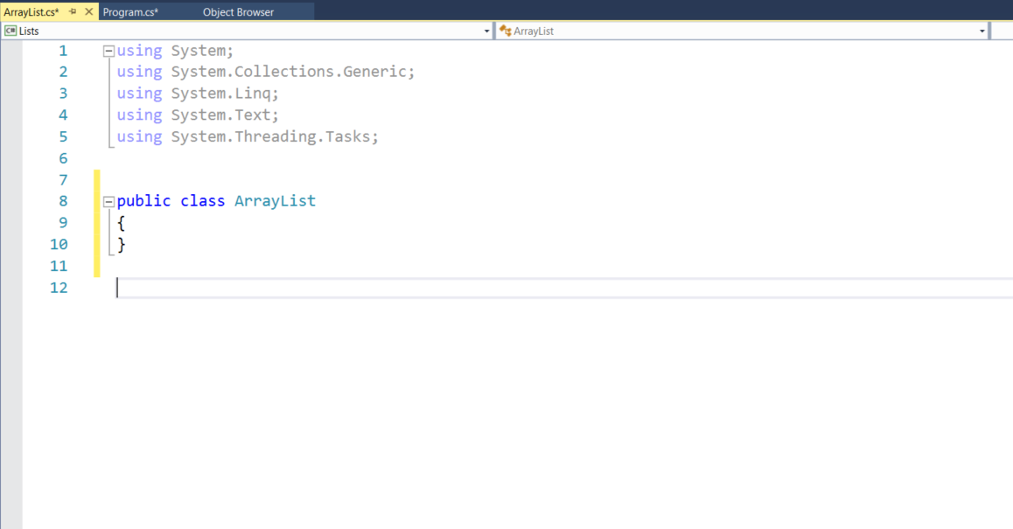Then, we write our class  
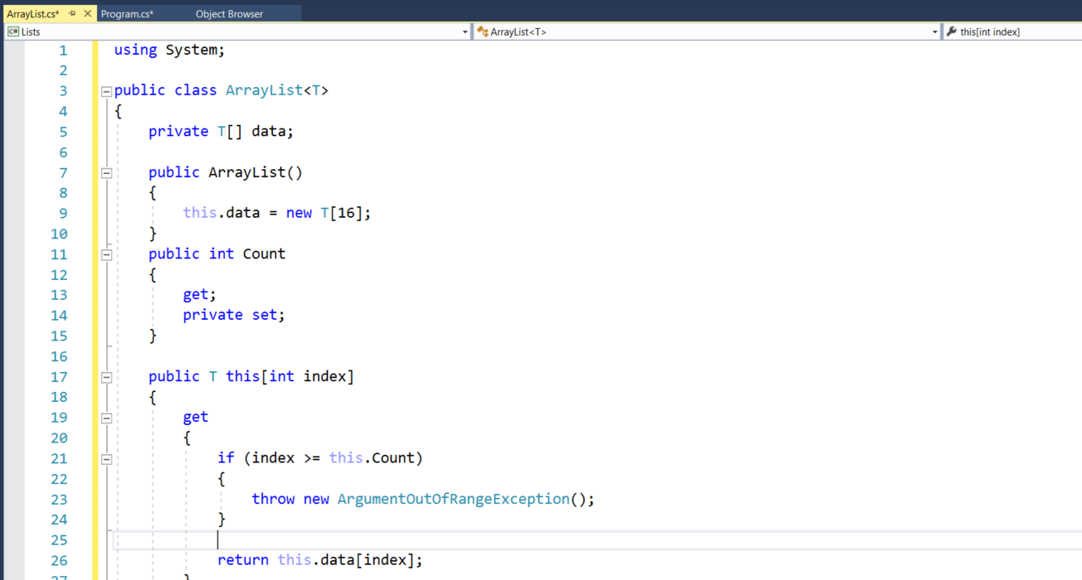

## Upload our Project in “Judge”

### Save our project and go to your project solution

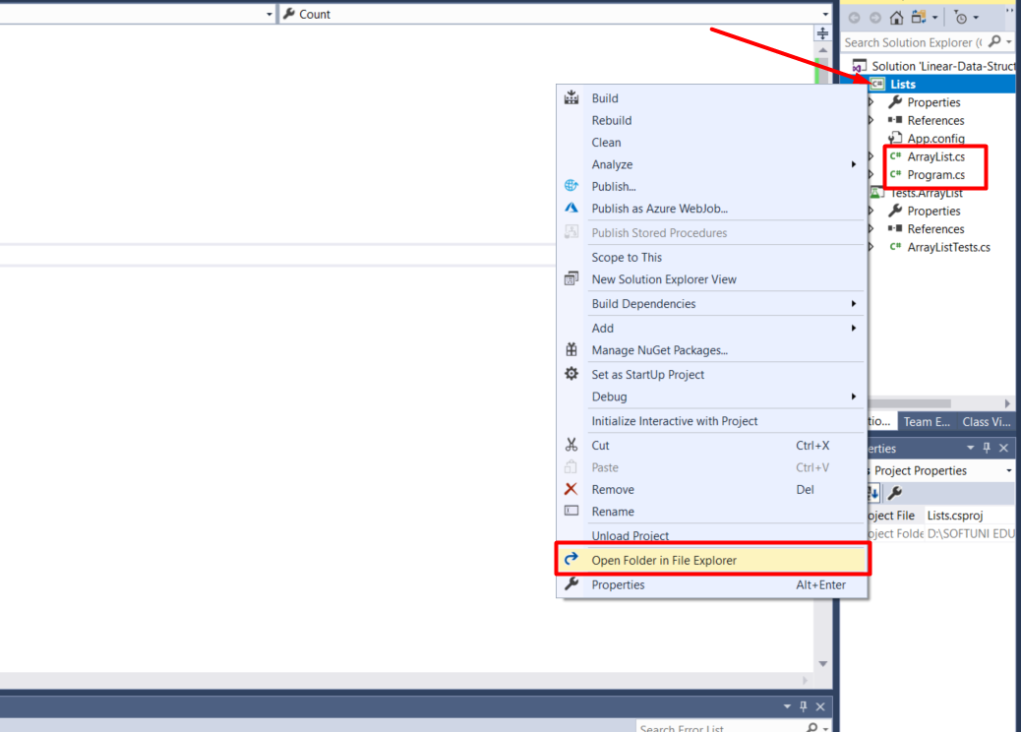

### Select all without “bin” and “obj” folders, then compressed it to ZIP

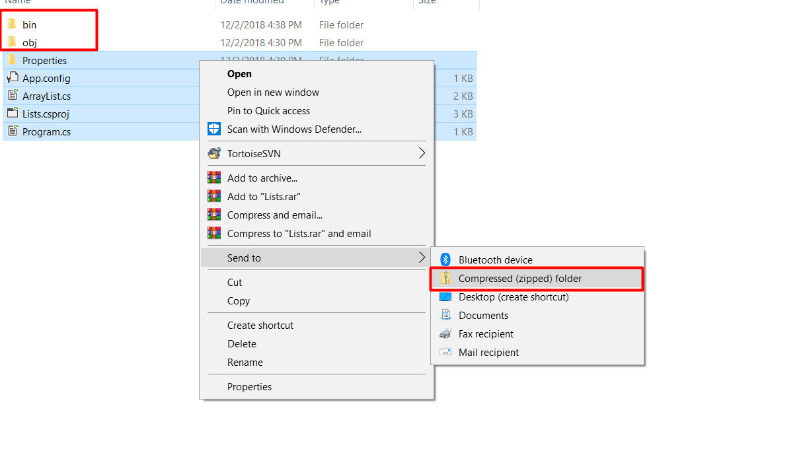

**Finally, we can submit our project(ZIP) in "Judge"** 